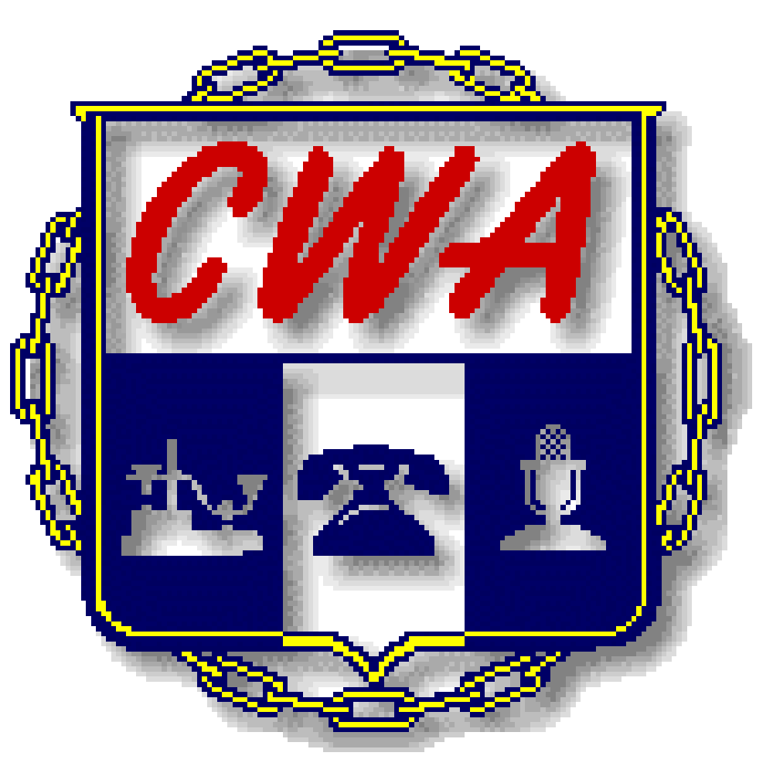

22nd ANNUAL CWA/AT&T CHARITY GOLF TOURNAMENT

WHO: FIRST 36 - 4 PERSON TEAMS

WHEN: SATURDAY, June 12th, 2021 – 8:00 AM SHOTGUN START
Registration begins at 7:00AM

WHERE: EAGLES LANDING-BELTON, MISSOURI

FORMAT: FOUR (4) PERSON SCRAMBLE

COST: $85.00 PER PERSON (includes mulligans)
Paypal available on our website listed below
(Please bring cash or check NO ATM on site)

INCLUDES: 18 HOLES OF GOLF, CART, FOOD, 2 DRINK TICKETS,
FUN AND AN OPPORTUNITY TO HELP THE FOLLOWING CHARITY:

WORKING FAMILIES FRIEND

ADDRESS: 4200 Bong Ave, Belton, MO 64012 SOFT SPIKES ONLY

Open to first 36 teams.
(Individual signups are welcome)

Entry forms are also available on the local’s website at www.CWA6360.org under the forms section.

Return only this page with payment.
--------------------------------------------------------------------------------------------------------

Make checks payable to: CWA/AT&T Charity Golf Classic

Send to: CWA Local 6360, 3675 S Noland Rd STE 201 Independence, MO 64055

Questions: Call Darrick Inscho at 816 561-6360 or email at Darrick@cwa6360.org

NAME: ____________________(Capt.) TELE # ________________________

NAME: _________________________TELE# _________________________

NAME: _________________________ TELE# _________________________

NAME: _________________________ TELE# _________________________
(PLEASE LIST ALL PLAYER NAMES)

Email Address for Team Captain and/or Players:

_______________________________________________________________

________________________________________________________________

________________________________________________________________

________________________________________________________________

ENTRIES MUST BE RECEIVED BY May 1st, 2021

