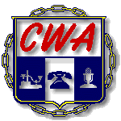

27th ANNUAL CWA/AT&T CHARITY GOLF TOURNAMENT

WHO: FIRST 36 - 4 PERSON TEAMS
WHEN: SATURDAY, June 13, 2026 - 8:00AM SHOTGUN START
Check-in starts at 7:00AM
WHERE: EAGLES LANDING-BELTON, MISSOURI
4200 Bong Ave, Belton, MO 64012

THE 27th ANNUAL CWA/AT&T CHARITY GOLF TOURNAMENT IS APPROACHING. WITH THIS IN MIND, THE TOURNAMENT COMMITTEE IS CONTACTING ALL PREVIOUS AND/OR NEW SPONSORS TO AGAIN PARTICIPATE IN A WORTHY CAUSE FOR CHARITY.

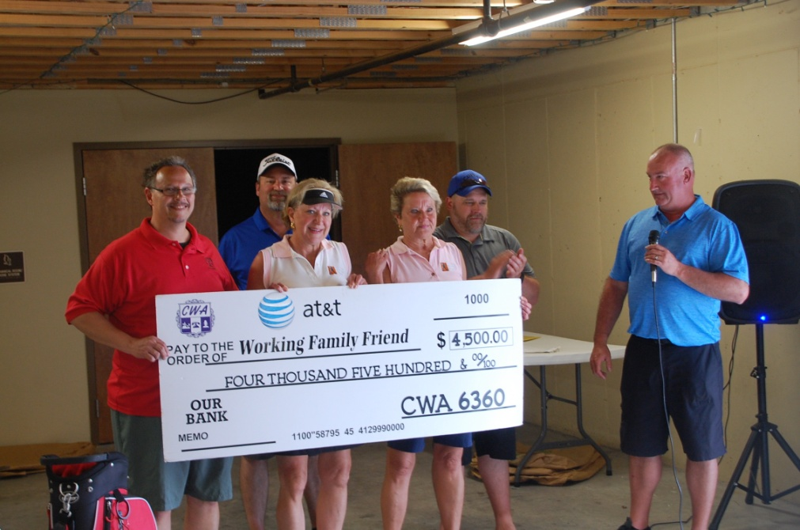

RETURN THIS PAGE WITH PAYMENT

Sponsor Name: ________________________________________________________

------------------------------------------------------------------------------------------------------
Make checks payable to CWA Local 6360

Send to CWA Local 6360, 3675 S Noland Rd Ste 201 Independence MO. 64055

Questions: Call Darrick Inscho at (816) 561-6360 or email: darrick@cwa6360.org

- $300.00 – Bronze Sponsor w/ Hole Sign and one (1) player

- $500.00 – Silver Sponsor w/ Hole Sign and two (2) players

- $750.00 – Gold Sponsor w/ Hole Sign and three (3) players

- $1000.00 – Platinum Sponsor w/ Hole Sign and four (4) Players

Signature________________________________

PLAYER NAMES:

NAME: ____________________(Capt.) TELE # ________________________

NAME: _________________________TELE# _________________________

NAME: _________________________ TELE# _________________________

NAME: _________________________ TELE# _________________________

Please provide emails if possible

